Accounting Systems:

Accounting begins with a chart of accounts. There are 5 types of accounts: Income, expenses, assets, liabilities and equity.
Income and expenses are used to record income and expenditure over time. Income minus expenses shows a profit or loss and provides a statement of performance (usually known as a profit and loss).
Assets and liabilities are used to record what the entity owns and owes. Assets minus liabilities provides a statement of position (usually known as a balance sheet) The balance of assets minus liabilities is the equity.

THE CHART OF ACCOUNTS
This is what I currently use:
The left hand column are the accounts the middle column is the description of the account and the right hand column is the current balance of the account.
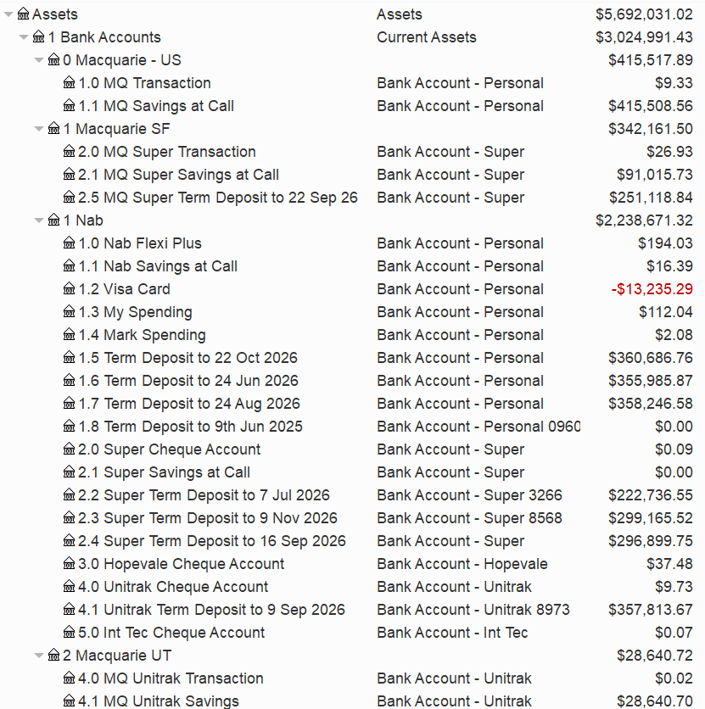
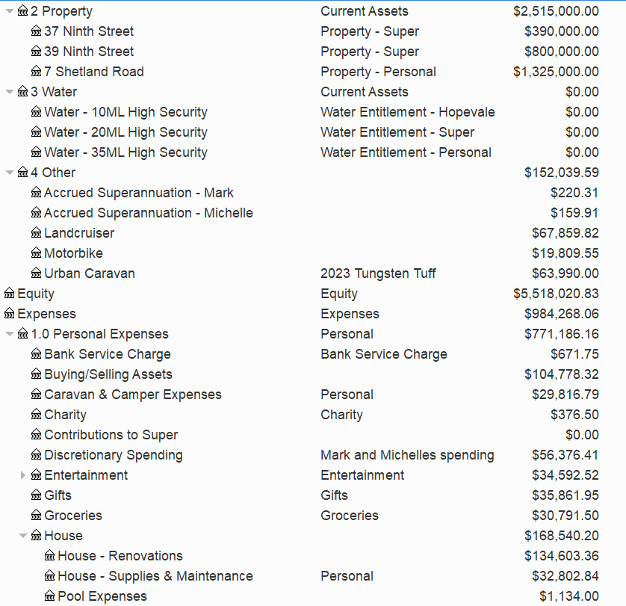
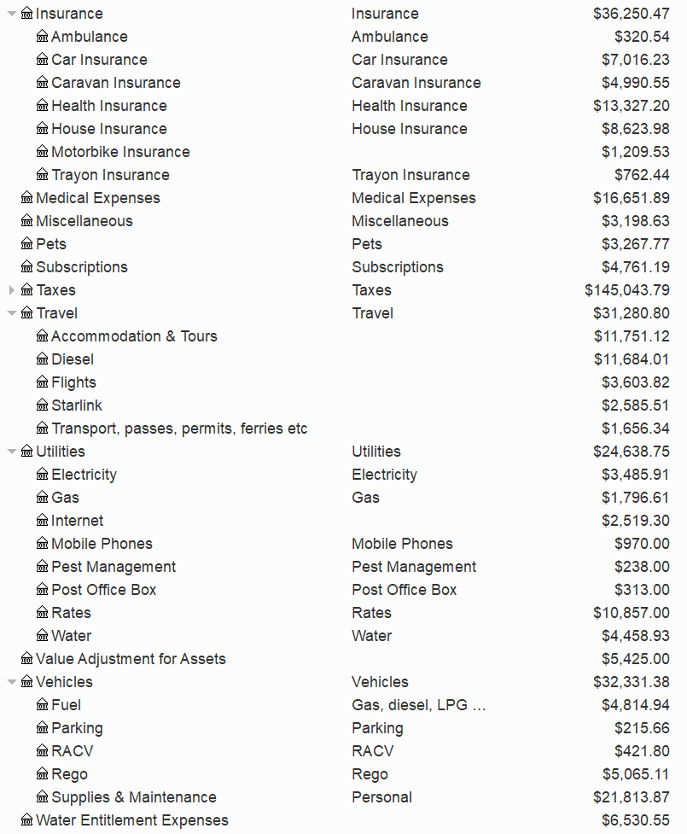
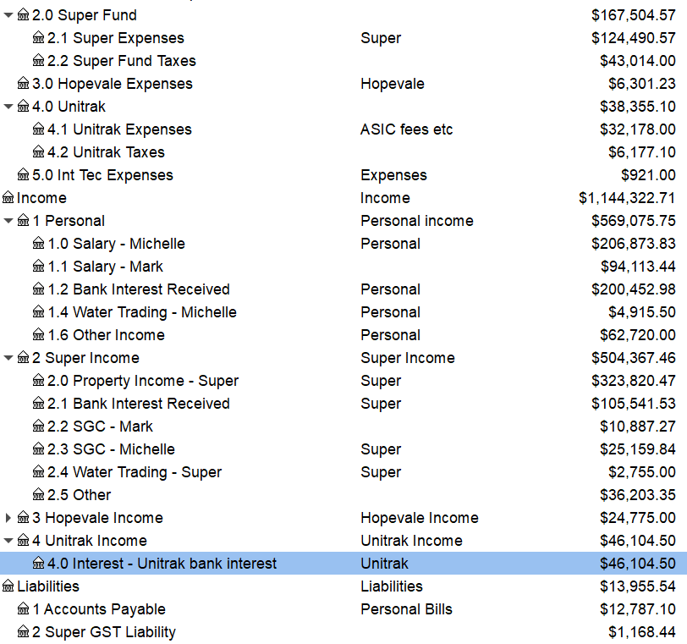

The accounts are on the left. There are main accounts and sub-accounts. The blue highlight can be ignored.
Each account has an account name, a description, a type (income, expense, asset, liability or equity). A checkbox to identify which assets are bank accounts would be nice. Being able select a colour for accounts would be great too.
It should also be possible to click on an account and see all transactions against the account.

